**EXAMINATION OF DRAFT REGULATORY LEGAL ACTS**

***Elena Ivanova***

*student, Amur State University,*

*Russia, Blagoveshchensk*

***Veronika Petrova***

*candidate of juridical sciences, associate Professor, Amur State University,*

*Russia, Blagoveshchensk*

The text of the article. The text of the article. The text of the article. The text of the article. The text of the article. "Quote" [1, p. 35]. The text of the article. The text of the article.

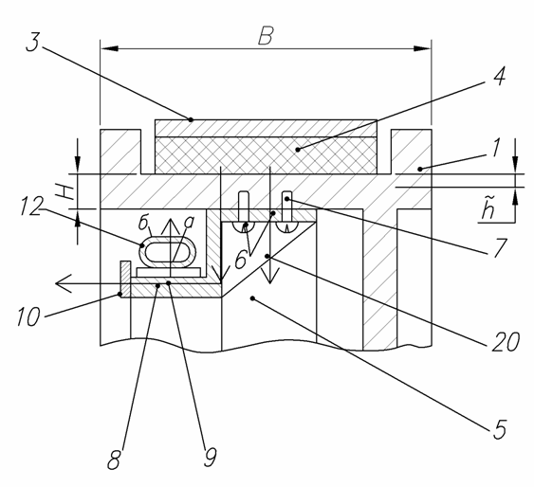

***Figure 1. The name of the figure***

The text of the article. The text of the article. The text of the article. The text of the article. The text of the article. "Quote" [1, p. 368]. The text of the article.

 (1)

где:  the amount of heat used to heat the pulley;

 mass of cargo moving at initial speed ;

 mechanical equivalent of thermal work;

 coefficient taking into account the conversion of kinetic energy into other types of non-thermal energy, uneven distribution of specific pressure and the actual contact area of the phase transition;

 distribution coefficient of heat flux FP.

The text of the article. The text of the article. The text of the article. The text of the article.

***Table 1.***

**Table name**

|  |  |  |  |  |
| --- | --- | --- | --- | --- |
| **Text** | **Text** | **Text** | **Text** | **Text** |
| Text | Text | Text | Text | Text |
| Text | Text | Text | Text | Text |
| Text | Text | Text | Text | Text |

The text of the article. The text of the article. The text of the article. The text of the article. The text of the article. "Quote" [2]. The text of the article.

References: